CEE 526 Finite Elements for Engineers

*Plane Elasticity Programming Project*

MichaelJustice

4/9/16

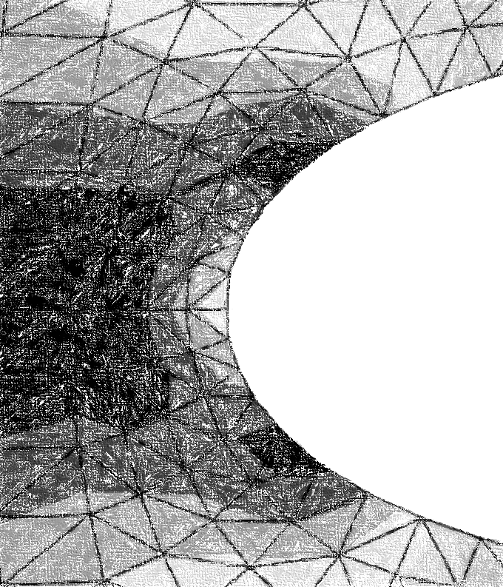

Contents

The Theory (A Succinct Summary) 2

# The Theory (A Succinct Summary)

This program was designed to analyze plane elasticity problems for both plane stress and plane strain. The elements used in the analysis were T6 elements (quadratic triangular elements) and as such, Gauss Quadrature was used to perform the numerical integration. The displacements, strains and eventually stresses were determined using plane elasticity equations. For plane stress,

$$\left\{\begin{matrix}σx \\ σy \\ τxy\end{matrix}\right\}=\frac{E}{1-ν^{2}}\left[\begin{matrix}1 & ν & 0 \\ ν & 1 & 0 \\ 0 & 0 & \frac{1-ν}{2}\end{matrix}\right]\left(\left\{\begin{matrix}ϵx \\ ϵy \\ γxy\end{matrix}\right\}-αΔT\left\{\begin{matrix}1 \\ 1 \\ 0\end{matrix}\right\}\right)$$

And plane strain,

$$\left\{\begin{matrix}σx \\ σy \\ τxy\end{matrix}\right\}=\frac{E}{\left(1+ν\right)\left(1-2ν\right)}\left[\begin{matrix}1-ν & ν & 0 \\ ν & 1-ν & 0 \\ 0 & 0 & \frac{1}{2}-ν\end{matrix}\right]\left(\left\{\begin{matrix}ϵx \\ ϵy \\ γxy\end{matrix}\right\}-\left(1+ν\right)αΔT\left\{\begin{matrix}1 \\ 1 \\ 0\end{matrix}\right\}\right)$$

From the equations above, the stresses were computed based on the elastic properties of the elements. The strains were determined based on the displacements of the nodes of the system, which was dependent on the shape functions evaluated at the Gauss points. A total of three Gauss points was used (Gauss Quadrature Rule of 2) to estimate the solution to solving for the Jacobian terms. Considering a T6 element was used in this program, the Jacobian was a function of the coordinates of the master element and non-linear. Using Gauss Quadrature, the stiffness matrix for the elements (and system) were approximated.

The element stiffness matrices were then assembled into the structural (or global) system so as to solve the elastic condition, $KD=F$. In order to solve for the nodal displacements, Cholesky Decomposition was used to decompose the stiffness matrix and perform factorization.

In order to form the structural nodal force vector F, the applied loads at the nodes and the traction loads were determined and then superimposed. The traction loads were determined in a similar manner to the stiffness matrix, and is shown below mathematically.

$$f_{i}=tT\oint_{Γ}{ϕ_{i}(\left[J_{12}dξ+J_{22}dη\right]\hat{i}-[J_{11}dξ+J_{21}dη}]\hat{j})$$

Note that the above equation must be determined at every shape function that corresponds to the side of the element that is prescribed traction. Using the above equation and the applied nodal loads, the structural nodal force vector was determined.

Temperature at the nodes was also analyzed and is shown in the plane stress/strain equations above. The $ΔT$ value is a sum of the product of the shape functions that have a nodal temperature change applied and the temperature change.

Using these concepts, the stresses (and strains) were determined in the T6 elements at each Gauss point.